PRODUCT QUALITY CLAIM FORM OF JSC "VOLGABURMASH"
(Bits for the mining industry, to be completed by the customer)
CLAIM / COMPLAINT
Description
BIT IN USE
Bit Model
Serial Number
Installation Date
Removal Date
Total Meterage (Drilled), m
Wear Description
GENERAL INFORMATION
Company / Organization
Name of the Pit / Mine
MINING AND GEOLOGICAL CONDITIONS UNDER WHICH DRILLING WAS CONDUCTED
Rock Description
Protodyakonov Scale Strength Coefficient, f
UCS coefficient., MPa (7-366)
Water in the well (1-3)
Fracture coefficient (1 - 5)
MINING DRILLING EQUIPMENT
Drill Rig Manufacturer
Drill Rig Model
Drill Rig Number
Drill Pipe Diameter, inch
DRILLING PARAMETERS (REGIME)
PullDown Pressure (WOB) | operating |  | maximum
Rotary Speed (RPM) | operating |  | maximum
Air Pressure (according to the gauge in the cabin) | without water |  | with water
Tel: +7 (846) 300 8000 e-mail: mail@vbm.ru https://vbm.ru

PHOTOGRAPHS OF THE USED BIT
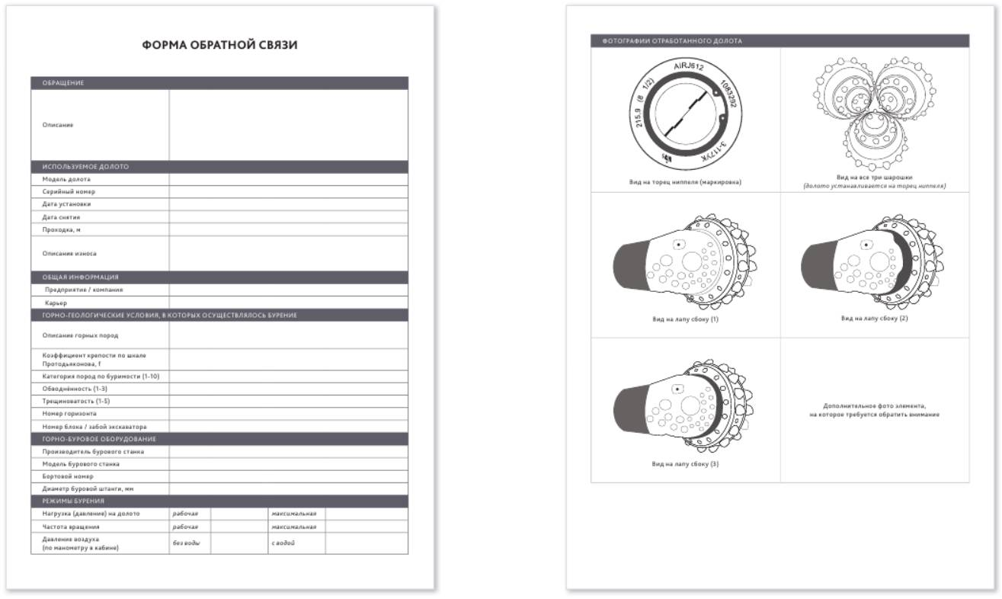  Pin End Face View (Marking) | View of the Three Roller Cones (Bit positioned on its pin end)
Side View of Leg (1) | Side View of Leg (2)
Side View of Leg (3) | Additional photo of the element requiring attention

Tel: +7 (846) 300 8000 e-mail: mail@vbm.ru https://vbm.ru

