PRODUCT QUALITY CLAIM FORM OF JSC "VOLGABURMASH"
(Drilling bits for the oil and gas industry, filled out by the customer)
DESCRIPTION OF THE QUALITY PROBLEM
Reason for the claim and description
BIT IN USE
Bit Model
Serial Number (as per bit passport)
Installation Date and Specifics
Removal Date
Drilling Interval, m or ft
Meterage (Drilled), m or ft
Bit Life (Hours in Service), h
Wear Description
GENERAL INFORMATION
Company / Organization
Contact Information (Full Name, Phone, Email)
Field / Facility
DRILLING CONDITIONS
Geological and Stratigraphic Section (lithological description of formations, etc.)
DRILLING EQUIPMENT
Derrick/Rig Manufacturer
Derrick/Rig Model, Number |  | Model |  |  |  |  | Number
Drill Rod Diameter, mm
DRILLING PARAMETERS (REGIME)
Bit Weight (WOB)
Bit Performance Statistics
Rate of Penetration (ROP), Drilling Method |  | Mechanical Speed |  |  |  | Drilling Method
Motor Type and RPM |  | Type |  |  |  | Rotary Speed, RPM
Drilling Fluid Parameters
Mud Pump Pressure
Pump Type and Capacity |  | Type |  |  |  | Flow Rate / Capacity
 | Tel: +7 (846) 300 8000 e-mail: mail@vbm.ru https://vbm.ru

PHOTOS OF THE USED DRILLING BIT
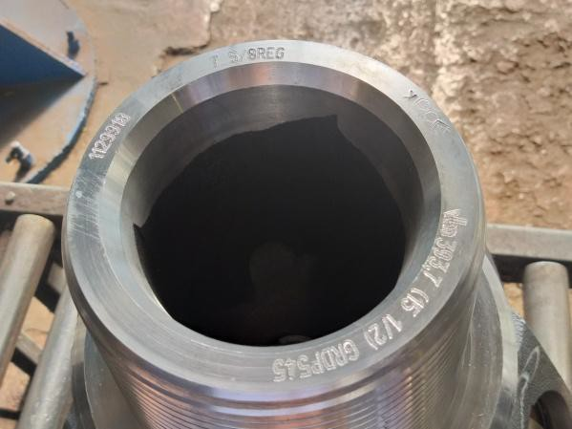 |  | 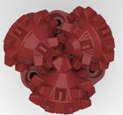  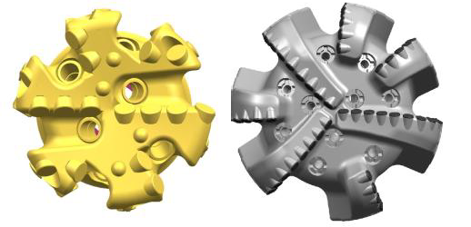
Pin End Face View (Bit Marking) |  | View of the Roller Cones or PDC Cutters (Bit positioned on its pin end)
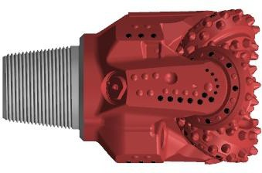 |  | 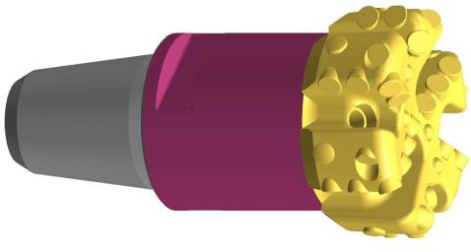
Side view of the leg/bit (1) |  | Side view of the leg/bit (2)
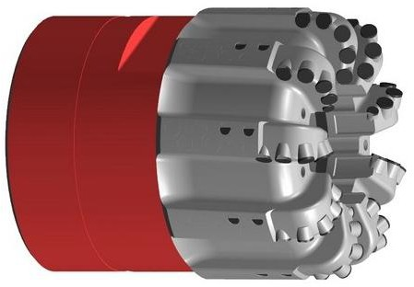 |  | 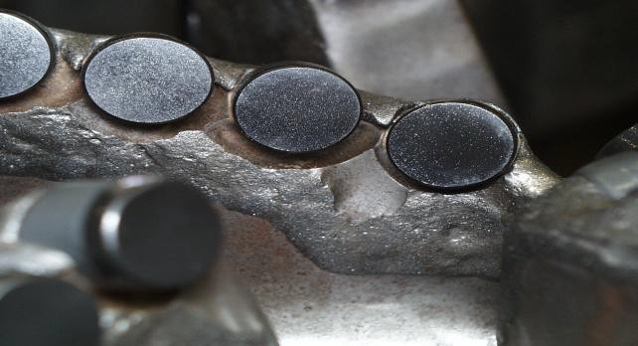
Side view of the leg/bit (3) |  | Additional photo of the element requiring attention
 | Tel: +7 (846) 300 8000 e-mail: mail@vbm.ru https://vbm.ru

