PRODUCT QUALITY CLAIM FORM OF JSC "VOLGABURMASH"
(Bits for the construction industry, to be completed by the customer)
CLAIM / COMPLAINT
Reason for inquiry and description

BIT IN USE
Bit model
Serial Number (as per bit passport)
Installation date and specifics / Installation details and date
Removal date
Drilling interval, m
Meterage drilled / Penetration, m
Bit Life / Bit service life, hrs
Wear description
GENERAL INFORMATION
Company / Enterprise
Contact Details (Full Name, Phone, Email)
Field / Site / Location
DRILLING CONDITIONS
Geological and Stratigraphic Section (lithological description of strata, etc.)
DRILLING EQUIPMENT
Drill rig/Equipment manufacturer
Drill rig model and serial number |  | Model |  |  |  |  | Number
Drill pipe diameter, mm
DRILLING PARAMETERS
Weight on Bit (WOB)
Bit performance statistics
Rate of penetration (ROP), Drilling method |  | ROP |  |  |  | Drilling method
Motor type and Rotary speed (RPM) |  | Type |  |  |  | RPM
Drilling fluid (Mud) parameters
Mud pump pressure
Pump type and capacity |  | type |  |  |  | capacity
 | Teл: +7 (846) 300 8000 e-mail: mail@vbm.ru https://vbm.ru

ФОТОГРАФИИ ОТРАБОТАННОГО ДОЛОТА
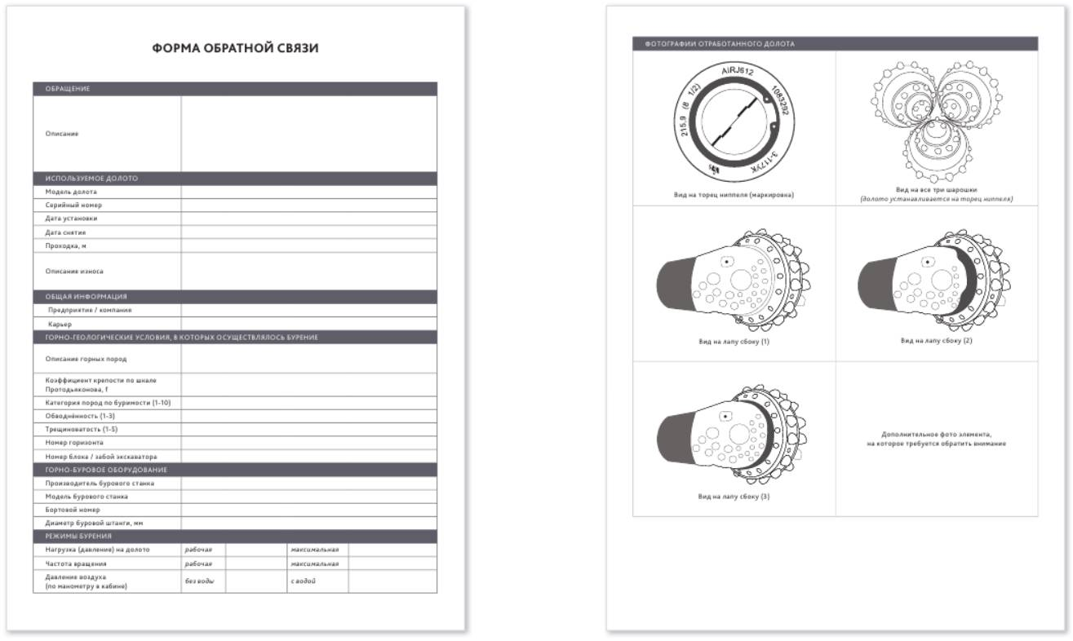  Pin End Face View (Marking) | View of the three roller cones (bit positioned on its pin end)
Side View of Leg (1) | Side View of Leg (2)
Side View of Leg (3) | Additional photo of the element requiring attention

Teл: +7 (846) 300 8000 e-mail: mail@vbm.ru https://vbm.ru

